Architectural Design

Team 7 심우석 – 201636417

전수환 – 201835519

박한음 – 201835461

1. **Architectural Pattern**

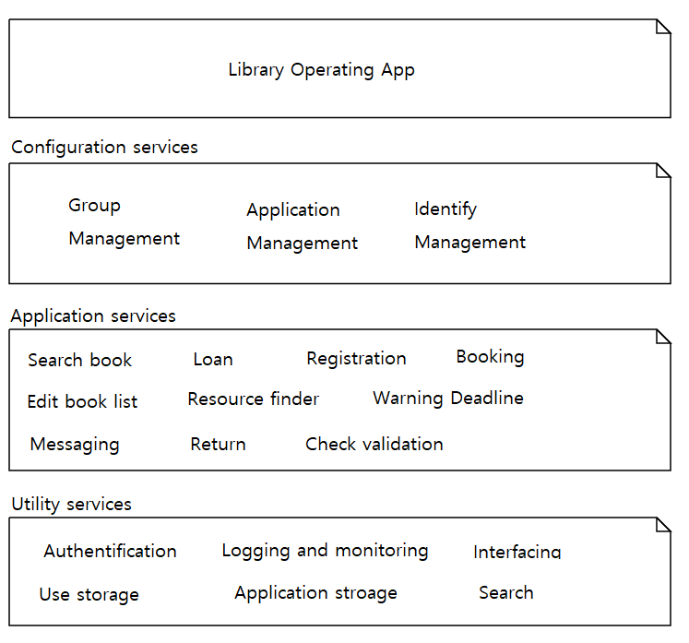**1.1 The Layered architecture pattern**

By using a layered architecture pattern, it will increase security.

The most important user and administrator information and book database, we will put at the bottom of program.

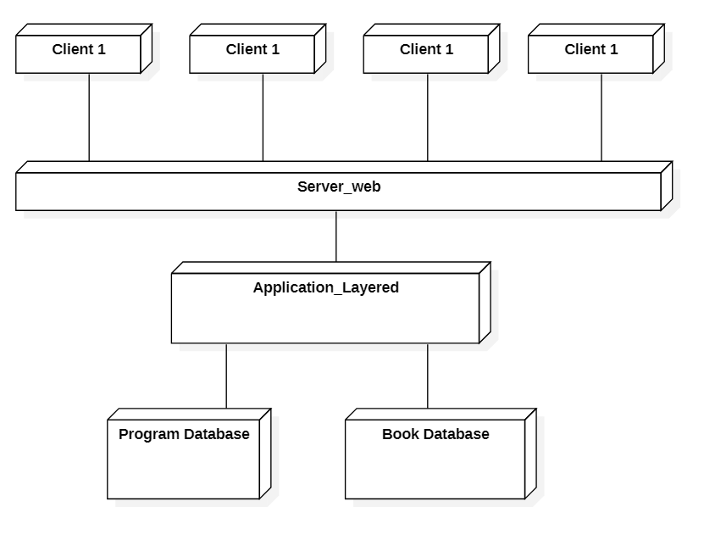**1.2 The Client – server pattern**

The program will be made in a layered system. It will also increase the interoperablility by connecting it to a web server. Since the program is connected to the webserver, it will be possible to modify, delete, add, etc. as long as the Internet is connected anytime, anywhere.

1. **Architectural views**
   1. **지도, 텍스트이(가) 표시된 사진

      자동 생성된 설명Logical view**
   2. 지도, 테이블, 책상, 전체이(가) 표시된 사진

      자동 생성된 설명**Process view**
   3. 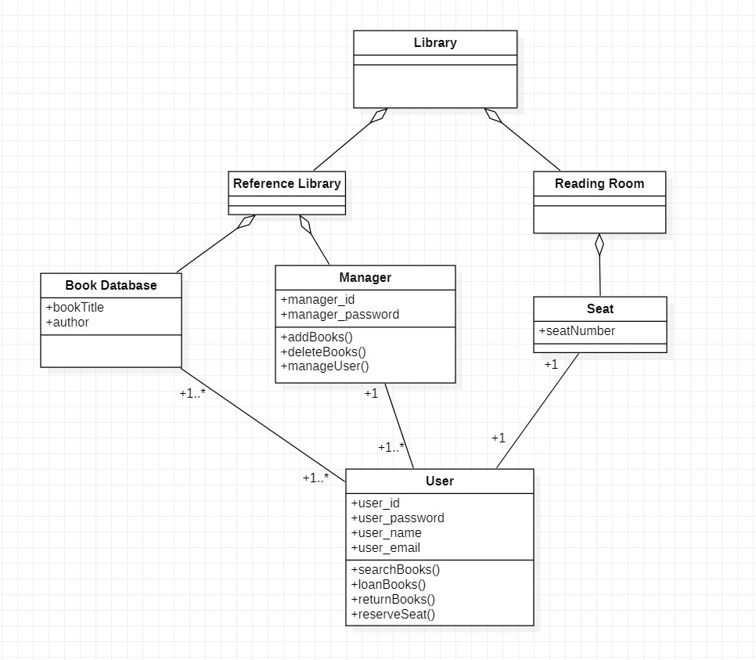**Development view**
   4. 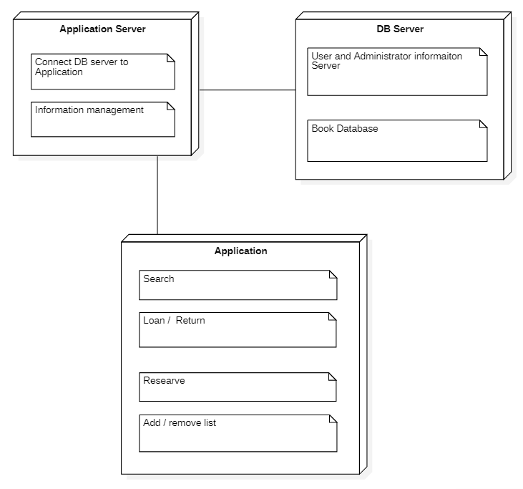**Physical view**
2. **Procedural / Component Design**

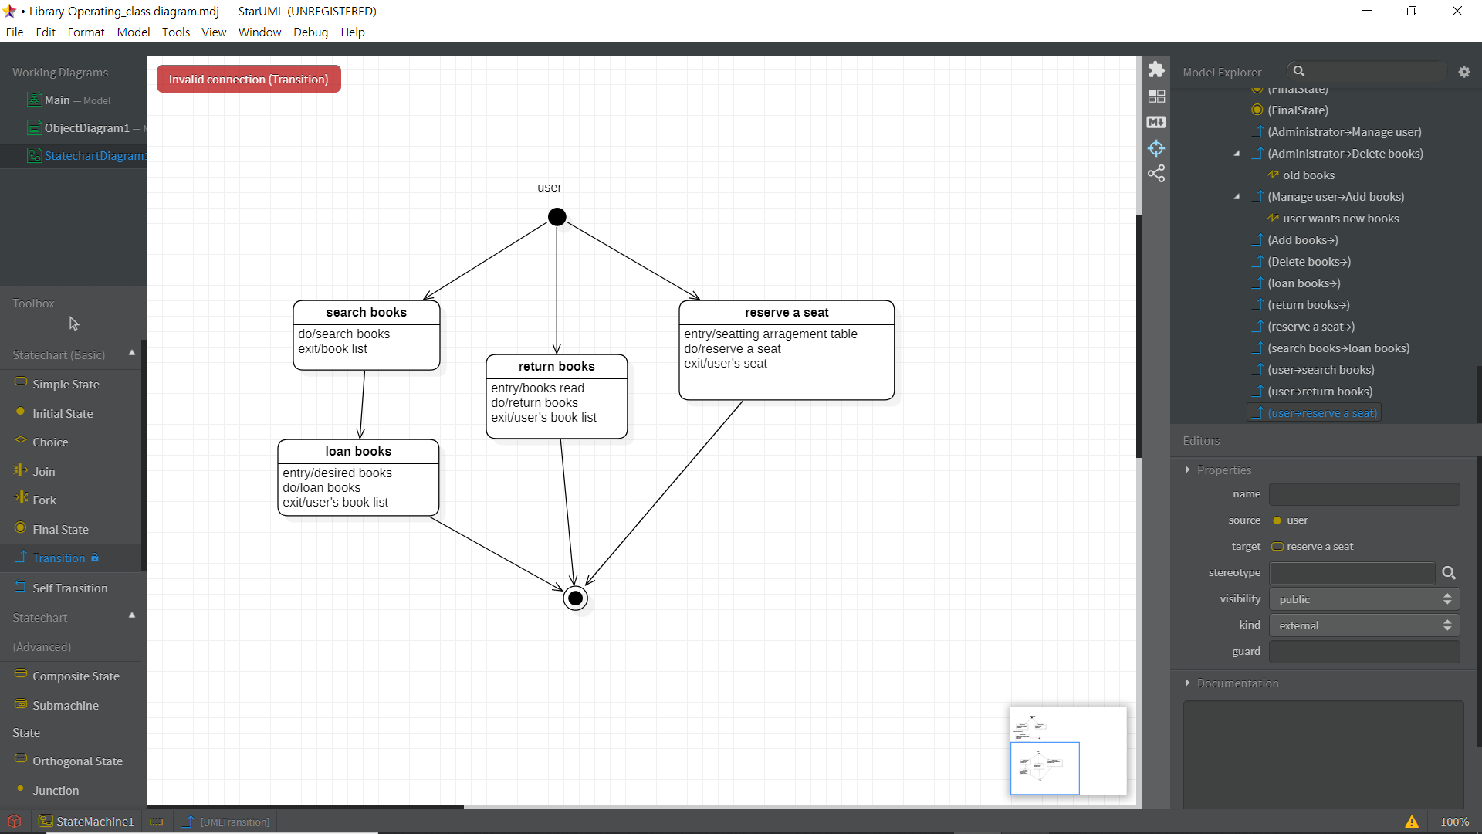**3.1 <User>**

**3.2 <Administrator>**

1. 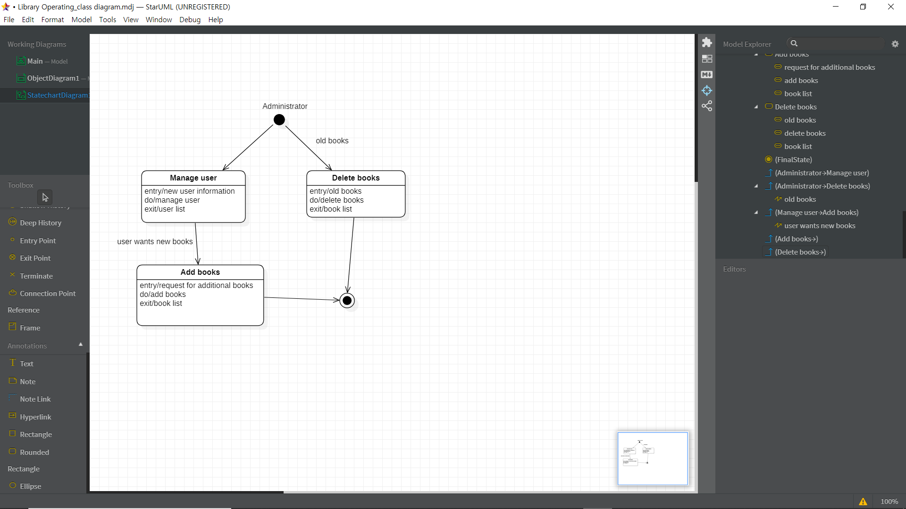**텍스트, 지도이(가) 표시된 사진

   자동 생성된 설명Interface Design**

Based on this diagram, user information and search books using the management system, and librarians edit and manage book lists using the management system and database.